P200-Why the adapters failed to establish a powerline network

Product line: powerline question category: trouble shooting

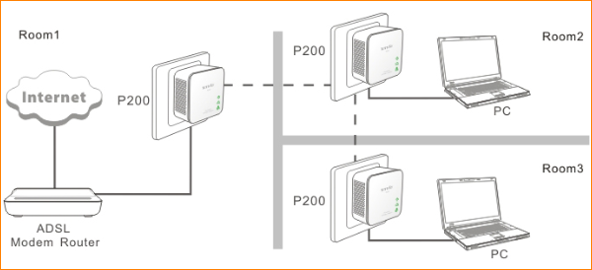

Reasons:

They are plugged into the different electricity meters.

2.They can’t find the same network name from the other powerline devices .

Solutions：

1.Please plug the P200s into the same electricity meters. The power line adapter only work in the same electricity meter.

2.Please press the Reset/Pair button for at least 10 seconds of all the P200 to restore them to factory default, so that they will have the same network.

A. After reset, please wait for about 2 minutes then check the Powerline light of all the P200, if they are all on or blinking fast, it means that they have established the powerline network successfully.

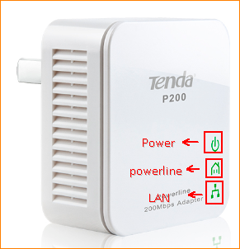

B. If the powerline light is still off or flashing slowly, please press the Reset/Pair button for about 3 second for the first P200, then do the same thing on the other P200 within two minutes.

Tips: Please setup the powerline network in the same outlet or in the same room first, then take them apart to the places or rooms where you want to use them.

